Ideation Phase
Define the Problem Statements

Date | 31 January 2025
Team ID
Project Name
Maximum Marks | 2 Marks

Customer Problem Statement Template:
The Customer Problem Statement helps us understand the difficulties faced by tenants, property owners, and administrators during the house rental process. It allows the development team to identify real user needs and build a solution that makes renting and managing properties easier, faster, and more secure.
A clear customer problem statement helps the team design a user-friendly HouseRent Management System that solves common rental problems, improves the overall user experience, and builds trust between tenants and property owners. Understanding these challenges also helps create features that are simple, reliable, and useful for everyone using the platform.
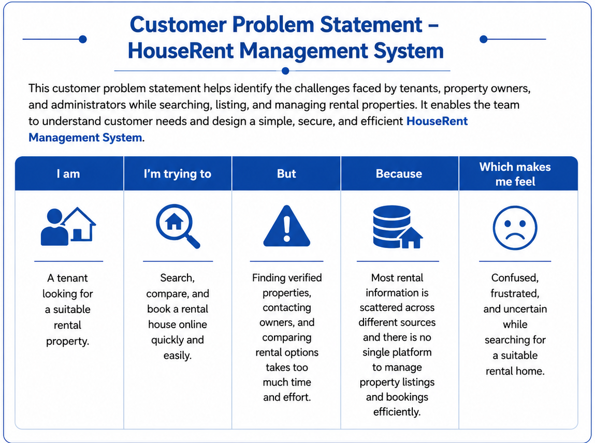

Reference: https://miro.com/templates/customer-problem-statement/
Example:
